Technology Stack (Architecture & Stack)
Project Design Phase-II

Date | 12/09/2026
Student Name | Navya Sri Tangellamudi
Project Name | Intergalactic Space Travel Request System (ISTR)
Maximum Marks | 4 Marks

Technical Architecture
The diagram below shows the ISTR technical architecture: how the Requester interacts with the Service Catalog, how the ServiceNow platform (custom table, Flow Designer, ACLs, SLAs, and reporting) processes the request, how it integrates with notification and external services, and how the Admin manages launch and audit.
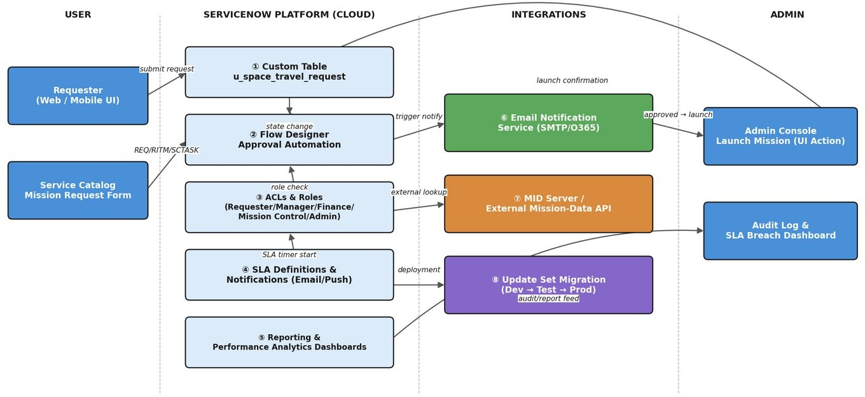

Figure 1 — ISTR Technical Architecture

3-Tier Layered Architecture
Zooming into the same architecture from a layering perspective makes the separation of concerns explicit — presentation, logic, and data each evolve independently, which is what lets ISTR add new mission types or approval stages (NFR-6 Scalability) without redesigning the core.
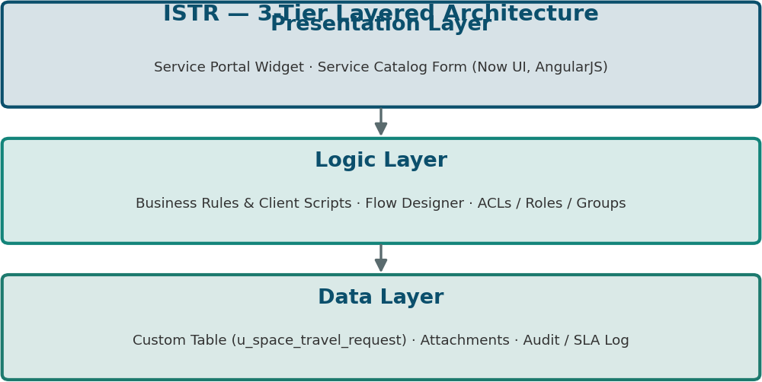

Figure 2 — ISTR 3-Tier Layered Architecture

Table-1: Components & Technologies

S.N  o | Component | Description | Technology
1. | User Interface | How the user interacts with the application | Service Portal Widget / Service Catalog Form (Now UI, AngularJS)
2. | Application Logic-1 | Mission request intake and validation logic | ServiceNow Business Rules & Client Scripts
3. | Application Logic-2 | Approval routing and orchestration logic | Flow Designer
4. | Application Logic-3 | Role and access control logic | ACLs, Roles & Groups (Platform Security)
5. | Database | Core data storage for mission requests | ServiceNow custom table (u_space_travel_request)
6. | Cloud Database | Database service on cloud | ServiceNow instance database (multi-instance cloud)
7. | File Storage | Attachment storage requirements | ServiceNow Attachment (Now Platform storage)
8. | External API-1 | Notification delivery to stakeholders | Email/SMTP Notification API
9. | External API-2 | Optional external mission-data lookups | MID Server / REST Integration
10. | Machine Learning Model | Future risk-assessment scoring for missions | Predictive Intelligence / AI risk-scoring model (planned)
11. | Infrastructure (Server / Cloud) | Application deployment. Local Server Configuration: N/A. Cloud Server Configuration: ServiceNow multi-instance SaaS (Dev / Test / Prod) | ServiceNow Cloud (SaaS), Update Set migration

Release Pipeline
Changes move through ServiceNow's standard multi-instance promotion path, packaged as Update Sets — this is what NFR-5 (Availability) relies on for low-downtime migrations between environments.
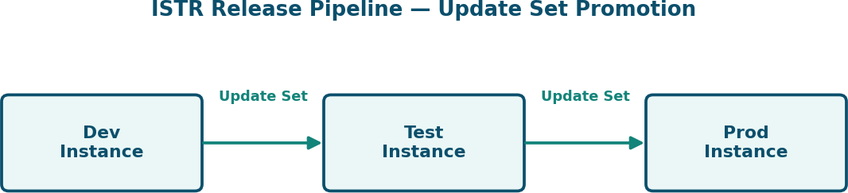

Figure 3 — ISTR Dev → Test → Prod Release Pipeline

Table-2: Application Characteristics

S.N  o | Characteristics | Description | Technology
1. | Open-Source Frameworks | Open-source frameworks used for UI and scripting | AngularJS (Now UI Framework), Bootstrap
2. | Security Implementations | Security / access controls implemented, use of firewalls etc. | ACLs, Role-Based Access Control, Data Encryption at rest & in transit (TLS), IAM, MFA
3. | Scalable Architecture | Justify the scalability of architecture | Modular table + Flow Designer design (3-tier: Presentation/Service Catalog, Logic/Flow Designer, Data/Custom Table) allows new planets, mission types,

S.N  o | Characteristics | Description | Technology
 |  |  | and approval stages without core redesign
4. | Availability | Justify the availability of the application | Multi-instance SaaS with built-in redundancy and load balancing across ServiceNow data centers
5. | Performance | Design considerations for performance | Indexed custom table queries, async Flow Designer execution, notification queuing to avoid blocking requests

Architecture Notes
- The Logic layer is deliberately split three ways (intake validation, approval orchestration, access control) so each concern can change independently — a new approval stage only touches Flow Designer, not the underlying table schema.
- The Machine Learning row is marked 'planned' — ISTR v1.0 ships with deterministic, rule-based risk flagging; predictive risk-scoring is a documented future enhancement, not part of the current build.
- File Storage and the Audit/SLA log both ride on native ServiceNow platform capabilities, keeping the stack free of external storage dependencies for this release.

